Raider Theatre
7391 Neshoba Road
Germantown, TN 38138
901-756.2300
RiverdaleTheater@gmail.com

Dear Sponsor,
Riverdale School will be hosting a spring musical titled “Disney’s Frozen Jr.”, April 2-5, 2020. We are raising funds that will be used in the production of our spring musical “Disney’s Frozen Jr.”. We are asking you to help by becoming a sponsor. Your generosity would be greatly appreciated and acknowledged at our event.

Diamond Sponsor - $1000
(2 available)

- Name on the Poster Distributed to Businesses Around Town
- Placement on the Riverdale Website
- Name Mentioned at the Beginning of the Performance
- 8 Complimentary VIP Tickets, Seating at Table with Refreshments and VIP Parking
- Full Page Color Ad in the Playbill

Platinum Sponsor - $500 or more

- Name on the Poster Distributed to Businesses Around Town
- Placement on the Riverdale Website
- Name Mentioned at the Beginning of the Performance
- 6 Complimentary VIP Tickets
- Full Page Black and White Ad in the Spring Musical Playbill

Gold Sponsor - $300

- Name Mentioned at the Beginning of the Performance
- 6 Complimentary VIP Tickets
- Half Page Ad in the Spring Musical Playbill

Silver Sponsor - $150

- Name Mentioned at the Beginning of the Performance
- 4 Complimentary VIP Reserved Seating Tickets
- Quarter Page Ad in the Spring Musical Playbill

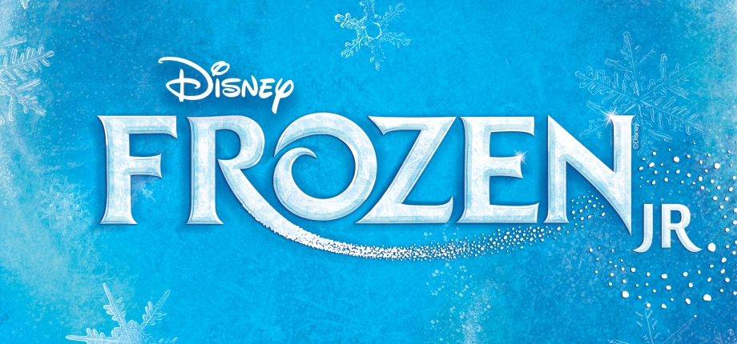
Riverdale Raider Theater
April 2-5, 2020
Sponsorship Form

Name ____________________________________________________________________________________________
Address___________________________________________________________________________________________
City_____________________________________________State__________________________Zip_________________
Telephone_________________________________________________________________________________________
E-Mail Address______________________________________________________________________________________
___$1000 Diamond ___$500 Platinum ___$300 Gold ___$150 Silver

You will not be able to use MYSCHOOLBUCKS for your reservations if you would like to become a sponsor.
Please email request to Melanie.moss@gmsdk12.org
Thanks,
Melanie Moss

